Office Notice 04/2020: Health Screening Programme
A revised Health Screening Programme for OPW staff is now available. This programme has been revised to reflect the feedback from Partnership and staff on the previous programme. The significant change in the 2020 programme is that staff can arrange for health screening with their own GP or a Health Screening provider and the OPW will contribute the sum of €60 towards the cost incurred by the staff member. The 2020 Health Screening Programme may be availed of by all staff, who are in employment with the OPW.
Purpose:
The purpose of Health Screening is to identify certain conditions, which, if undetected, could lead to more serious health problems later in life. The health screening programme is confidential between the individual staff member and the health screening provider. The OPW will not seek any personal medical information arising from the health screening process.
Conditions:
If the cost incurred by the staff member is less than the contribution, the lesser sum will be contributed by the OPW.
No additional or further contribution will be made by the OPW if;
- the cost of the health screening is in excess of the OPW contribution amount or
- if the staff member avails of more than one screening or attends for a related or resultant medical appointment, or
- if the staff member incurs travel or other expenses in connection with attending the screening appointment(s).
The possible contents of health screening vary from provider to provider and the contents are a matter for the staff member in consultation with the provider. Guidelines on medical screening from the Office of the Chief Medical Adviser are attached for information at Appendix B.
The costs of health screening can vary considerably from provider to provider; you are advised to give due regard to the potential costs involved before entering into a screening process.
Attendance:
Health screening appointments should, where possible, be made for times outside of working hours. Where this is not possible, appointments should be sought for times towards the beginning or end of the working day / shift. Local management may be in a position to facilitate a staff member who has to take time off work, up to a maximum of 2.5 hours, to attend a screening appointment. In such circumstances, the staff member must provide documentary confirmation to the local manager of attendance at the appointment.
Procedure for staff who wish to participate in the programme:
- Please obtain prior approval for attendance at a health screening appointment from your line manager.
- You make arrangements for health screening with your chosen provider and you undergo your chosen screening requirements.
- You pay the health screening provider the full costs of the health screening and you obtain a receipt for your payment. The receipt should clearly show the details of the health screening provider and should state that your payment was for health screening.
- You send the receipt to Mr Gerard Knightly, Human Resource Management, OPW HQ, Trim (or scanned emailed copy to gerard.knightly@opw.ie ), at any time, but no later than 31st October 2020, referencing the Health Screening Programme.
- The Purchase to Pay (P2P) system will be used by HR to process the payments of the OPW contribution sum. If you are not set up as a supplier on the P2P system, please complete the New Supplier Form at Appendix A below and scan directly to: ptop@opw.ie or by post to:
The Office of Public Works
Accounts Payable
Government Buildings
Hebron Road
Kilkenny
R95 H4XC

- HR will process the payment to you of the OPW contribution sum; the payment will issue to your bank account and you will receive a remittance advice email when your payment is processed.

If you have any enquiries in relation to the Health Screening Programme or the OPW contribution payment arrangements, please contact Gerard Knightly in HR at email gerard.knightly@opw.ie or by phone 046 – 942 6859.

Mick Long
Director of Corporate Services
January 2020

Appendix A

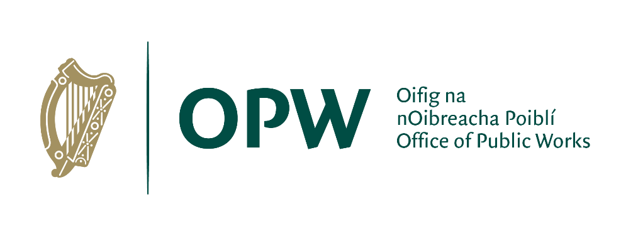

NEW SUPPLIER FORM

Please note details entered on this form should be as they appear on your invoices. Fields should be completed in BLOCK CAPITALS.

Supplier Name: ____________________________________________________

Trading Name: ____________________________________________________
(if different to
Supplier Name)

Supplier Address: _____________________________________________________

_____________________________________________________

_____________________________________________________

Where payments for the year are expected to exceed €10,000, a supplier must demonstrate tax compliance. In order for OPW to check your tax status with Revenue, you must provide your PPS Number or Tax Reference Number and Tax Clearance Access Number.

Supplier PPSN/ Tax Reference Number: ________________________________________

Supplier Tax Clearance Access Number: ________________________________________

Supplier Contact Name: ____________________________________________________

Contact Telephone
Number: ____________________________________________________

Under the Public Service Reform Plan, the Office of Public Works is committed to issuing all payments to its suppliers by means of Electronic Fund Transfer (EFT), whereby payments will be lodged directly to your Bank or Building Society. An email address should be provided to allow a remittance advice to be sent to you electronically at the time of payment.

Email Address for
Remittance Advices:

Email Address for
Purchase Orders: ________________________________________________

Name of Contact
Person in OPW: ________________________________________________

Please tick the box next to your preferred currency for payments issued by OPW:

Euro Sterling

Bank Details:
Sort Code:
Account Number:
BIC Code:
IBAN:
Account Name:
Bank Name:
Bank Address:

Signed:
Date:

The completed form along with bank account details should be sent by email to ptop@opw.ie or by post to the address below:

The Office of Public Works
Accounts Payable
Government Buildings
Hebron Road
Kilkenny
R95 H4XC

For use in OPW Accounts

Date Received (Date Stamp):

Data Input by: Date:

Checked by: (1) Date:

(2) Date:

Supplier Number: ______________________________
Appendix B

CMO Advice on Health Screening

Beneficial tests:
- Blood pressure
- BMI & Waist Circumference
- Cholesterol & Triglycerides
- Glucose or Glycated Haemoglobin

Possibly Beneficial tests:
- Full blood count
- Renal profile
- Liver function tests
- Thyroid Function tests
- Bone profile
- Urinalysis
- Atrial Fibrillation Screening
- Vision Test (for VDU)

Benefit Uncertain tests:
- Resting ECG
- Bone Density
- Uric Acid
- Lung Function

Best provided by National Programme/ General Practitioner
- Breast/ Cervical/ Colon & Prostate Cancer Screening
- Haemochromatosis Screening

