Toolbox Talk

COVID-19 Worker Representative
Site:
Date:
Delivered By:
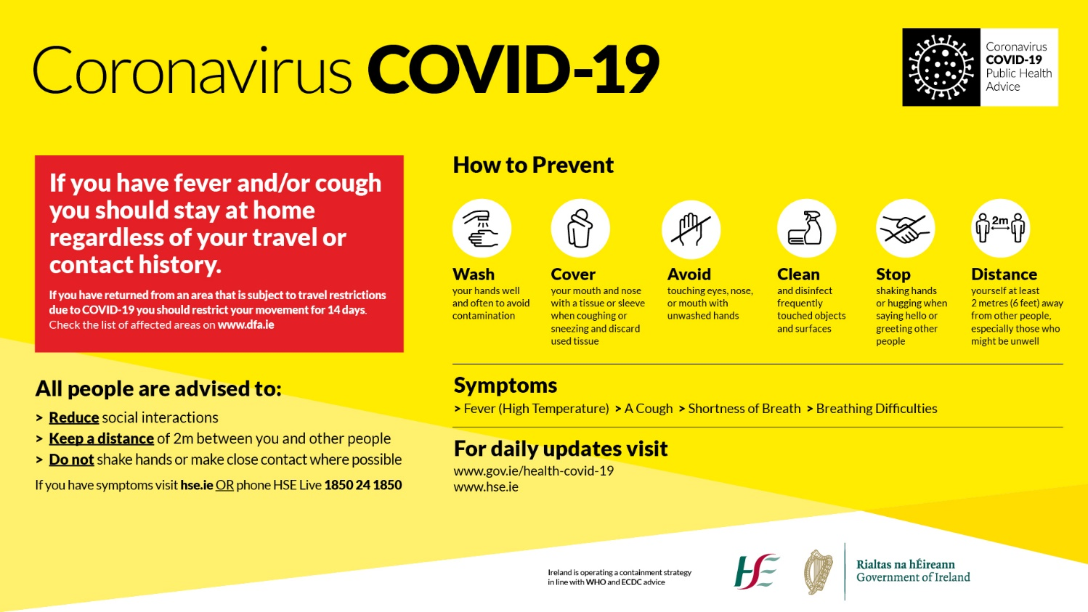
The aim of this toolbox talk is to outline the role and duties of a COVID-19 Worker Representative.

COVID-19 Worker Representative(s) under the ‘Return to Work Safely Protocol’, must be appointed by the OPW to oversee local implementation in each workplace. These people should be clearly identifiable and will act in collaboration with the health and safety representative, safety officers, local managers and staff in each workplace.

Due to the wide range of workplace environments and roles across the Office, the OPW considers that a number of Worker Representatives are required to be appointed across its various workplaces. Depending on the workplace, more than one person may be appointed, or in some cases, a person will act as an alternate if required.

People appointed to carry out this role may include any staff member who is a representative of and for the staff.

Compliance with control measures is the responsibility of everyone.

Role of a COVID-19 Worker Representative

- Work collaboratively with the OPW Management to assist in the implementation of measures;
- Monitor adherence to the measures to prevent the spread of COVID -19; and
- Support the implementation of the identified measures.

Duties of a COVID-19 Worker Representative

- Monitor the day-to-day work activities within their designated area, to support management in ensuring that COVID-19 control measures are being maintained, in order to protect health and reduce the risk of spread of the COVID-19 virus.
- Assist management and workers in complying with the 2-metre physical distancing rule and good hygiene practices. Note: Site Management should communicate all details of site operations to the appointed COVID-19 Worker Representative.
- Follow the framework provided by the OPW i.e. COVID-19 Toolbox Talk, Coronavirus (COVID-19) Risk Assessment, Weekly Checklists. This structure will be regularly reviewed and updated as required.
- Ensure that they do not put themselves at risk while carrying out their duties.
- Promote and monitor compliance with HSE guidelines including physical distancing of 2 metres between all personnel on site, and good hygiene practices.Complete relevant COVID-19 checklists.
- Check appropriate contact logs are maintained.
- Check that there is sufficient up-to-date signage erected, in order to inform all personnel about the COVID-19 controls on site.
- Check regular cleaning is undertaken, of welfare facilities - handrails, door handles, tools, etc.
- Check water and hand-drying facilities are available.
- Check soap and hand sanitisers are replenished as required.
- Check site/office personnel are adhering to break time schedules and limiting numbers in canteens, drying rooms and smoking areas cognisant of the 2-metre physical distancing guideline.
- Report any areas of non-compliance or defects to site management and follow-up to seek to have them addressed.
- Inform site management of any concerns raised by site personnel.
- Consider recommendations for improvements of existing controls and/or provision of additional controls and discuss with management.
- Engage with elected safety representatives, where applicable, to ensure any concerns or recommendations for improvement are brought to the attention of management.
- Keep up to date with HSE guidelines.

Remember:
- Ensure that you do not put yourself at risk while carrying out your duties.
- Be cognisant of the need at times for discretion and confidentiality.
- The situation is constantly evolving, so additional duties may be added or amended in line with Government /OPW updates.
- Compliance with control measures is the responsibility of everyone.

Please refer to:
- Risk Assessment Coronavirus (COVID-19)
- COVID-19 Induction
- COVID-19 Weekly Checklist
- COVID-19 First Aid Responder Toolbox Talk
- Site Specific Risk Assessments and/or procedures

Subject | COVID-19 Worker Representative
I confirm that this topic has been brought to my attention
Name (Block Capitals): |  | Signature:
Any Comments:

