Local Authority COVID-19 Work Safely
Health and Safety Operational Guidance
Roadworks Programmes

Date: 12th May 2020

Contents
1. Executive Summary 3
2. Introduction 5
3. Typical Activities Associated with the Annual Road Works Programmes 5
4. Phased Return to Work 7
4.1. Phase 1: Programme Level Planning 7
4.2. Phase 2: Project Level Planning 8
4.3. Phase 3: Construction 8
4.4. Phase 4: Ongoing Review and Oversight 8
5. Supply Chains 8
5.1. Bitumen 9
5.2. Road Surfacing Contractors 9
5.3. Stone, Chips, Sand & Gravel 10
6. COVID-19 Control Measures 10
6.1. HSE Guidelines 10
6.2. Compliance with COVID-19 Control Measures 11
6.3. Travel To/From Work 11
6.4. Inductions, Toolbox Talks and Site Meetings 12
6.5. Tools, Plant & Equipment 12
6.6. Close Working Activities 12
6.7. Welfare Facilities 15
6.8. Management of Deliveries to Sites 16
6.9. Site Visits 16

Executive Summary
This submission considers how roadworks construction can be undertaken throughout the Local Authority Sector, during the COVID-19 Pandemic and it goes on to recommend the restarting of the construction programme in a controlled and managed way. It sets out some standard practices that can be applied in a uniform manner across all Local Authorities while still allowing for variations to suit local circumstances.

This document was prepared by Donegal County Council in conjunction with Wexford County Council on behalf of the LGMA. The document has been approved by the Local Authority Health & Safety Operational Committee and the Joint Union/Management Health & Safety Steering Committee.

In preparing this document, discussed on the various components were had with other local authorities and other key stakeholders. In addition, regard was had to the document produced recently by the Construction Industry Federation (CIF) regarding Standard Operating Procedures. The work by the CIF is acknowledged here. Many of the procedures are similar to those already operating in the Local Authority sector and they are not repeated here.

This document should be read in conjunction with the LGMA High Level Local Authority COVID-19 Work Safely Health & Safety Guidance.

The document covers the following:

- The typical nature of the types of roadworks that are undertaken, the nature of the long and open air sites, the type of work that is largely done by machinery with a limited number of workers spread out on site;
- The advance planning and approvals that must be completed before starting any construction works on-site including designs, risk assessments and associated control measures, procurement, method statements, staff travel, parking and welfare arrangements and levels of supervision and oversight required;
- The chain of responsibility from suppliers, contractors, machinery operators, Council crews and oversight personnel;

- The primary objective of limiting the spread of COVID-19 from our work activities and the necessary measures to achieve this objective;
- The ability to re-start work on a phased basis and to ramp-up the activity if successful.

Introduction
The impact of COVID-19 across the world has been profound. Widespread restrictions have been introduced that has seen economic and physical activity reduced to levels never seen before. It would appear however that this approach has been effective to the extent that governments can now look towards a gradual easing of the COVID-19 restrictions and as a result increasing economic activity.
This document has been prepared to outline the various activities involved in the Road Works Programme and to outline control measures that will manage the risk of spreading COVID 19 during these works.
Local variations may be made to the standard practice measures set out in this document by individual Local Authorities to suit their own working arrangements. The measures will be kept under review and updated as necessary as national and organisational guidance evolves.

Typical Activities Associated with the Annual Road Works Programmes
The main components of the Road Works Programme are Restoration Improvement (pavement strengthening), Restoration Maintenance (surface dressing), Community Involvement Schemes (CIS), Bridge Rehabilitation, Low Cost Safety schemes, Road Drainage repair & renewal and Local Improvement Schemes (LIS).

Strengthening, Surface Dressing and CIS represent the largest elements of the Road Works Programme and the process followed in completing these works generally involves some or all of the following tasks;
- Scoping and Agreement with Elected Members
- Planning and Design
- Site Preparation
- Laying Bituminous Macadam/ Wetmix Macadam/ SMA/ HRA
- Surface Dressing
- Road Lining and Reflecting Road Studs
Other elements of the Road Works Programme follow a similar process for planning and design but construction activities can vary significantly. LIS projects tend to be similar to Surface Dressing projects.
Physical distancing is one of the key measures in the prevention of the spread of COVID-19 and Figures 2.1 and 2.2 below illustrate how this can be achieved in Pavement Strengthening and Surface Dressing operations.
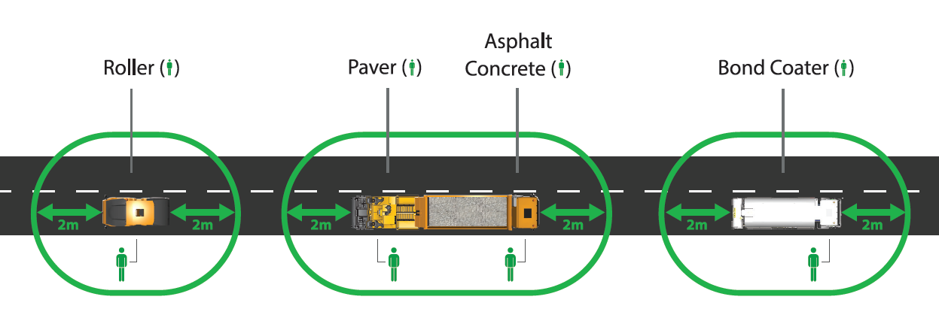
Figure 2.1: Physical Distancing During Pavement Strengthening Operations
Courtesy of Colas Ireland

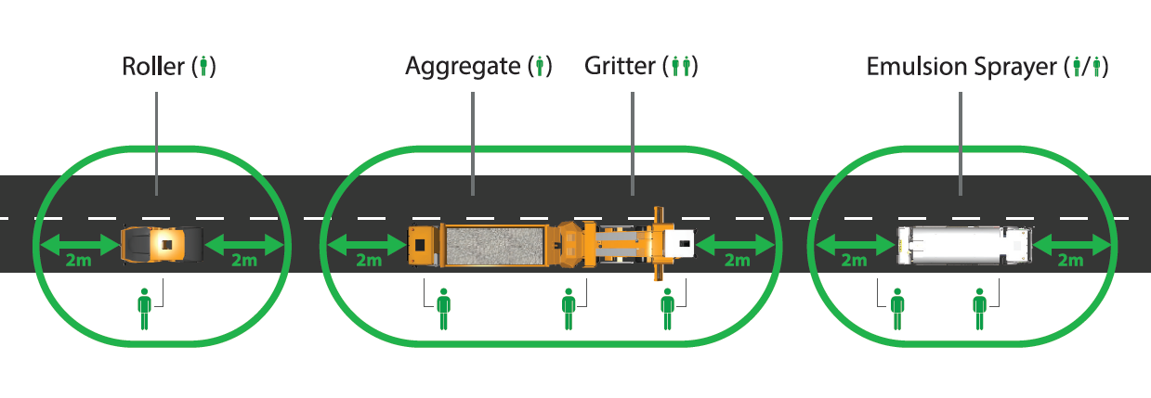
Figure 2.2: Physical Distancing During Surface Dressing Operations
Courtesy of Colas Ireland

The table below provides a summary assessment of the level of COVID-19 risk associated with pavement strengthening and surface dressing projects.

ASSESSMENT OF COVID-19 RISK WITH PAVEMENT STRENGTHENING AND SURFACE DRESSING ACTIVITIES
Stage | Activities | Status | COVID-19 Risk Level | COVID-19 Risk Level
1: Scoping | Draft Programme, Consult with EMs. | Complete | N/a | N/a
2: Planning and Design | SD & Overlay Design, Procurement of plant and materials. Preparation of TMPs, SSWPs, etc. | In Progress/ Complete | Can be done by one person working on their own via remote working and limited site visits | VERY LOW
3: Site Preparation | Traffic Management, Patching, Ledging, Drainage, Vegetation cut back. | Not Started | Use of plant and the dispersed nature of the site will allow for full implementation of physical distancing. | LOW
4: Bituminous Macadam/ Wetmix/ SMA/ HRA | Batching material, Plant and materials deliveries to site, Traffic Management, Laying materials, raising ironwork, verges. | Not Started | Use of plant and dispersed site will allow for full implementation of physical distancing. Some need to share vehicles and equipment but low risk when standard COVID-19 control measures are applied. | LOW
5: Surface Dressing | Plant and materials deliveries to site, Traffic Management, applying Tar & Chips. | Not Started | Use of plant and dispersed site will allow for full implementation of physical distancing. Some need to share vehicles and equipment but low risk when standard COVID-19 control measures are applied. | LOW
6: Lining and Road Studs | Mixing paint, applying lines, applying lettering, installing road studs | Not Started | Full implementation of physical distancing is possible. | LOW

Phased Return to Work
It is proposed that the early focus will be on trialling the COVID-19 operating protocols. To this end a number of smaller projects should be selected in each district to allow the workforce to become familiar with the COVID-19 operating protocols.
It is proposed that the easing of COVID-19 restrictions would allow work on the 2020 Road Works Programme to gradually increase, broadly along the following phases;

Phase 1: Programme Level Planning
- Each county to identify component(s) of the Road Works Programme proposed to be commenced first;
- Review and amendment of Risk Assessments and Standard Operating Procedures to account for the COVID 19 risk;
- Engage with contractors and suppliers to arrange for the implementation of COVID 19 risk management protocols;
- Prepare method statement(s) in accordance with the Council’s safety policies and COVID-19 operating protocols.

Phase 2: Project Level Planning
- Review project specific constraints to confirm that the project can be constructed in compliance with the Phase 1 Method Statement(s);
- Develop project specific health and safety management documents e.g. Traffic Management Plan, Safe System of Work Plan, etc.
- Make arrangements for all necessary control measures to be in place at the commencement of construction;
- Review and sign-off of project level planning by local management;
- Provide feedback to Programme Level Planning teams.

Phase 3: Construction
- Provide site briefing/ Toolbox Talk to site operatives;
- Construction, onsite supervision by Supervisor/ Foreman;
- Oversight by local engineering staff;
- Provide any feedback to Programme & Project Level Planning team.

Phase 4: Ongoing Review and Oversight
- Agree schedule of site visits and inspections by Health and Safety Officers & Management;
- Undertake inspections;
- Periodic discussion of inspection findings (Weekly at first and reducing if no non-compliance issues arising);
- Provide any feedback to Programme & Project Level Planning teams.

Supply Chains
In order to assess the potential impact on the spread of COVID-19 from the reactivation of supply chains discussions were had with various industry figures to gauge the level of risk associated with their operations and also the availability of materials used in their own supply chains.

Bitumen
Bitumen suppliers should be contacted to confirm that they have an adequate supply of all stock products available and arrangements have already been made for physical distancing during the manufacturing process.

Bitumen suppliers provide two different services;
- Bulk Supply of Bitumen to Local Authorities, and;
- Supply and Spray.
In both scenarios it is possible for the tanker/ sprayer drivers to spend the majority of their time on site in their vehicle and when outside it is possible to remain apart from other workers on site and adhere to COVID-19 operational protocols.
Road Surfacing Contractors
Road Surfacing Contractors have already assessed their operations and developed procedures to manage the COVID-19 risk. In general road surfacing operations involving Bituminous Macadam and Stone Mastic Asphalt tend to be spread out over long lengths of roadway and would naturally facilitate physical distancing. Achieving physical distancing during Hot Rolled Asphalt works may be more problematic as there is a need for a number of staff to congregate around the chipper. A separate assessment will be needed to develop standard procedures for this work.
There can often be a requirement for staff to travel long distances to get to work sites, including travel between counties. Travel to/from sites is normally via a shared vehicle in which the feasibility of physical distancing is limited. Options for compartmentalising the cabs of these vehicles are being explored at present and are expected to be finalised in the coming weeks. As an interim measure Contractors will be expected to abide by the control measures set out in section 6.4 below.
The most significant COVID-19 related risk to road surfacing operations arises if one of a contractor’s key personnel becomes unavailable due to self isolation, infection, etc. Some operatives are highly skilled and experienced and not easily replaced.

Stone, Chips, Sand & Gravel
In general, most quarries continue to operate to service customers who have been deemed to be providing an essential service, albeit at a much reduced level than normal. Quarry operators have already assessed their operations and developed procedures to manage the COVID-19 risk.
Quarries had also generated large stockpiles of materials early in the year before the current COVID-19 restrictions were introduced. This is normal practice in preparation for the Local Authorities annual Road Works Programmes and as such no significant problems are expected with supplies of quarry materials. In the event that current restrictions are relaxed to allow for road strengthening and/or surfacing to restart, associated trades/suppliers, e.g. explosives for blasting, will also need to be included.

COVID-19 Control Measures
It is expected that COVID-19 risks will need to be considered for each project and worksite individually. Each Local Authority will need to consider the COVID-19 risk in the context of their own work practices and develop protocols to manage this.
The following guidance has been prepared as suggestions for managing some of the more common scenarios that arise and to demonstrate that the COVID-19 risk is manageable while progressing the Road Works Programme.

HSE Guidelines
Current HSE advice is that COVID-19 could be spread by people who do not exhibit symptoms therefore adherence to the HSE guidelines to prevent the spread of COVID-19 is a fundamental prerequisite before any work activity can proceed. Full up to date details of HSE Guidelines can be found at https://www2.hse.ie/conditions/coronavirus/coronavirus.html. The primary control measures relevant to road maintenance work are;
- Frequent hand washing – after coughing or sneezing, before and after eating, before having a cigarette or vaping, if your hands are dirty and after toilet use;
- Do not touch your eyes, nose or mouth if your hands are not clean;
- Physical distancing – keep a space of 2 metres (6.5 feet) between you and other people, avoid crowded places, do not shake hands or make close contact with other people;
- Cough etiquette – cover your mouth and nose with a tissue or your sleeve when you cough or sneeze and put used tissues into a bin and wash your hands;
- Clean and disinfect frequently touched objects and surfaces;

Compliance with COVID-19 Control Measures

The Chief Executive may assign responsibility for COVID–19 compliance to a specific person(s) for the duration of the pandemic. This will be a decision for each individual Local Authority. Monitoring compliance will require ensuring that physical distancing, hygiene rules and COVID–19 control measures are being adhered to and maintained in order to reduce the risk of the spread of COVID-19.

It is important to note that compliance with COVID-19 control measures is the responsibility of everyone and must be supported by all in order to protect health and reduce the spread of COVID-19.
All Risk Assessments, SSWPs, Health and Safety Policies and Procedures, etc. should be reviewed and amended as necessary to include control measures for COVID-19. Copies of these amended documents should be circulated and communicated to staff via Toolbox Talks.

Travel To/From Work
- The occupancy level of vehicles is to be minimised and single occupancy for vehicles is preferable.

- If more than one per person per vehicle, the following measures should be followed:
- Employees should not enter a work vehicle with others if they have any symptoms or have had contact with a confirmed case of COVID-19.
- Sit as far apart as the vehicle allows.
- Passenger to travel in the back of the vehicle at left passenger side.
- Keep windows of vehicles open, at least partially.
- Practice good respiratory hygiene.

- Key touch points in vehicles are to be wiped regularly (e.g. door handles, steering wheel, handbrake, gear stick, radio controls) and hands sanitised before and after entering / exiting the vehicle. Hygienic wipes and hand sanitiser must be available for this purpose.

Note : IPB have agreed to extend the Local Authorities motor fleet policy to provide business use for these employees using personal vehicles for the period of the emergency. The cover level is agreed Comprehensive Cover. Management should keep a record of the employee’s name and private insurance policy number. This approach will need to be factored into project planning to ensure that adequate parking is available on site for the expected number of vehicles.

Note 2: We are aware that a review is taking place to assess the viability of partitioning vehicles to facilitate higher occupancy levels and these guidelines will be updated according. This will be a decision for each local authority. IPB has issued an advisory note to Local Authorities in relation to this issue. Local Authorities should ensure that they are informed about this item.

Inductions, Toolbox Talks and Site Meetings

- Inductions, toolbox talks & site meetings should be conducted if possible, in an open-air setting.

- Use ongoing toolbox talks to heighten and maintain awareness of employee responsibilities in the workplace in relation to physical distancing.

- The 2m distance must be adhered to.

- Rooms should be well ventilated/windows open to allow fresh air circulation.

- Employees should use own pen for signing site documentation.

Tools, Plant & Equipment

- Avoid the sharing of tools and equipment as much as possible.

- Where more than one person is likely to use equipment and tools then they should ensure they are wiped down between use and also hands sanitised before and after use.

- Cleaning materials must be made available for this purpose.

Close Working Activities

Physical distancing is one of the key measures in the prevention of the spread of COVID-19, however there may be limited situations where close working cannot be avoided e.g. lifting a wacker plate on/off a vehicle.

As a first step, all options to eliminate the close working activity must be exhausted, e.g. using a small self-drive roller in preference to a wacker plate or using a vehicle with a lifting aid that can be operated by one person.

The flow chart below is provided to assist in the review of work processes with physical distancing in mind.

Physical Distancing | Transmission Considerations | Plan of Action
Ref CIF COVID SOP 2020

Requirements for personnel prior to working within 2m of each other:
- Risk assessment carried out and control measures determined including PPE requirements.
- Limit the amount of time of close working to the absolute minimum.
- No employee, other than those required for the activity shall be permitted within a 2m exclusion zone.

Where possible / appropriate utilise:
- Barriers / partitions at points where regular interactions occur
- Increase ventilation levels
- Establish a 2m exclusion work zone

Hygiene to be maintained to a high standard:
- Clean hands before and after activity
- Avoid touching face
- Practice good respiratory hygiene and cough etiquette
- Work environment and equipment to be cleaned before and after activity
- Personnel to operate side by side, facing away from each other where possible

PPE required for close working activities is to be determined by Risk Assessment and local operating procedures.

Where used, PPE is to be removed and disposed of appropriately i.e. disposable PPE to be double bagged and placed in a bin and non-disposable PPE to be sanitised.

Welfare Facilities

Canteen facilities in local authority mobile welfare units are generally unsuitable for physical distancing. This will minimise the risk of cross contamination from frequently touched surfaces in communal areas.
Where use of the canteen facilities is unavoidable then COVID-19 information posters must be prominently displayed. Hand washing facilities, hand sanitiser and wipes must be available and staff directed to wash/ sanitise hands on entering and leaving the canteen. Attendance in the canteen must be staggered to ensure physical distancing.

Welfare Facilities / Eating on Construction Sites
- Shared site welfare facilities present a risk of transfer of COVID-19 and as a result must be fully considered in project planning.
- For the duration of the pandemic staff may be encouraged to take their breaks in their vehicles.
- If using canteen facilities, break times should be staggered to reduce congestion and contact.
- Cleaning materials should be provided at these locations and numbers using them limited according to the space available.
- All rubbish should be disposed of appropriately.
- Tables should be cleared by employees when finished eating and cleaning between each use.
- Employees should not share objects that touch their mouth, for example, bottles or cups.
- Ensure hands are washed before eating.
- COVID information posters should be prominently displayed

Toilet Facilities
- Employees must adhere to physical distancing when using toilet facilities
- Ensure adequate provision of soap and hand washing facilities.
- Provide clear pictorial guides for washing hands (See HSE Posters advice https://www.hse.ie/eng/services/news/newsfeatures/covid19-updates/partner-resources/ )
- Review and enhance the cleaning regimes for toilet facilities, particularly frequently touched surfaces such as door handles, locks, taps and the toilet flushing mechanisms.
- Provide suitable and sufficient rubbish bins for hand towels with regular removal and disposal.

Management of Deliveries to Sites

The following considerations should be made:
- All deliveries must be planned with allocated times for collections/ appointments/deliveries.

- Ensure that all delivery transactions adhere to physical distancing.

- During the delivery, if it is necessary for the driver to exit the vehicle, (i.e. to lift out materials / to open a lorry Tail Gate etc.), Physical Distancing of 2 metres from any other personnel at the depot / yard, must be maintained at all times;

- Where possible arrange for paperless delivery acceptance and request electronic copy of the delivery dockets.

Site Visits

Site visits by Area Engineers and other design/ supervisory staff undertaking preplanning and design work must be done in compliance with the following controls;

- Site visits are to be strictly limited to those necessary for preplanning for the 2020 Road Works Programme, i.e. scoping, preparation of Surface Dressing designs, Risk Assessments and Traffic Management Plans;
- No unnecessary stops are to be made;
- Interaction with the public or landowners on site should be avoided;
- A personal bottle of hand sanitiser is to be carried in the vehicle for use as required (e.g. after toilet breaks);
- HSE measures to prevent the spread of COVID 19 must be strictly adhered to at all times (physical distancing, hand washing/sanitising, etc.)
- All actions undertaken must consider and be done in a manner that will limit the spread of COVID-19.

